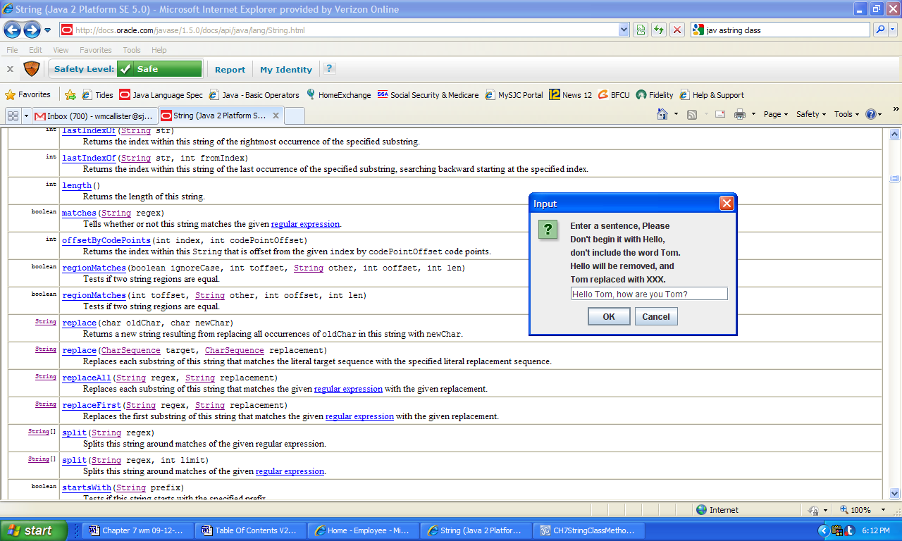 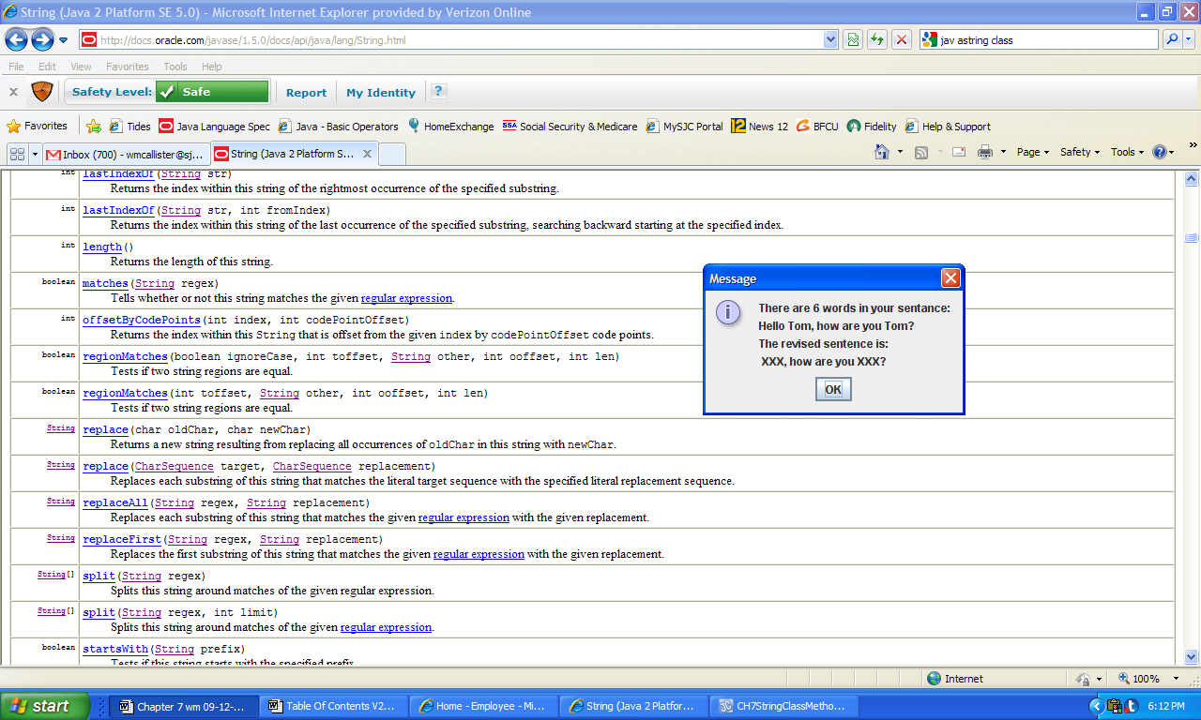

a) Input b) Output

**Figure 7.17 Input to the application StringProcessing and the corresponding output.**